**Bug report**

**Bug no.1:**

**Description:** The user is unable to navigate to homepage from ‘Popular Make’ screen

**Environment –** XYZ

**Date of test –** 07-08-2022

**Team/Project** - XYZ

**Application** – Buggy Cars Rating

**Created by** – Adarsh Ramasubramanian

**Assigned to** – Rakesh Chauhan

**Severity** – Damaging

**Priority** – Medium

**Reproducible** – Yes

**Parent story** – XYZ

**Pre-requisites** – Access to Buggy Cars Rating website

**Steps to reproduce:**

1. Login to <https://buggy.justtestit.org/>
2. Click on the ‘Buggy Rating’ label in the top left corner to go into homepage
3. Click on the ‘Popular Make’ cluster
4. Click on ‘Buggy Rating’ label in the top left corner to go into homepage again

**Expected result** – The user should land on the homepage

**Actual result** – The user isn’t able to go to homepage as the page doesn’t load

**Screenshots**:

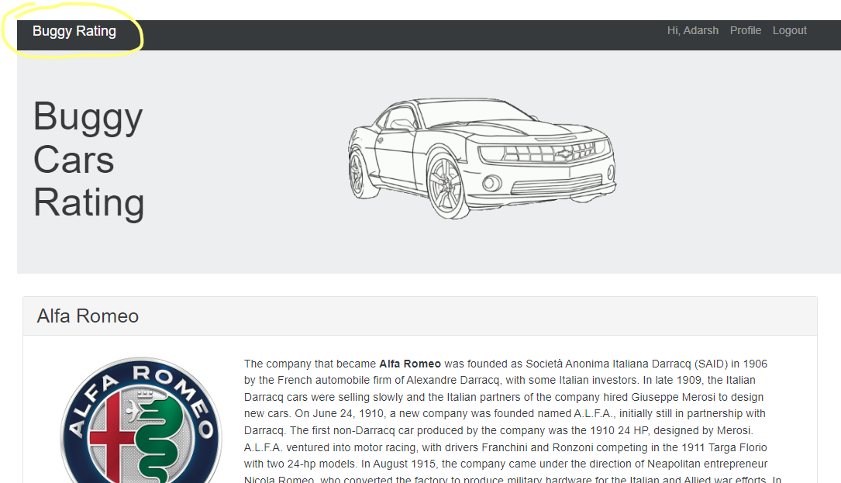

**Bug no.2:**

**Description:** The system allows to move to pages beyond the actual pages available in ‘Overall rating’ screen

**Environment –** XYZ

**Date of test –** 07-08-2022

**Team/Project** - XYZ

**Application** – Buggy Cars Rating

**Created by** – Adarsh Ramasubramanian

**Assigned to** – Rakesh Chauhan

**Severity** – Damaging

**Priority** – Medium

**Reproducible** – Yes

**Parent story** – XYZ

**Pre-requisites** – Access to Buggy Cars Rating website

**Steps to reproduce:**

1. Login to <https://buggy.justtestit.org/>
2. Click on the ‘Buggy Rating’ label in the top left corner to go into homepage
3. Click on the ‘Overall Rating’ cluster
4. Click on the ‘>>’ button to move to next page and try to go beyond the 5th page

**Expected result** – The user shouldn’t be able to move beyond the page limit 5

**Actual result** – The user is able to view unavailable pages after 5th page

**Screenshots**:

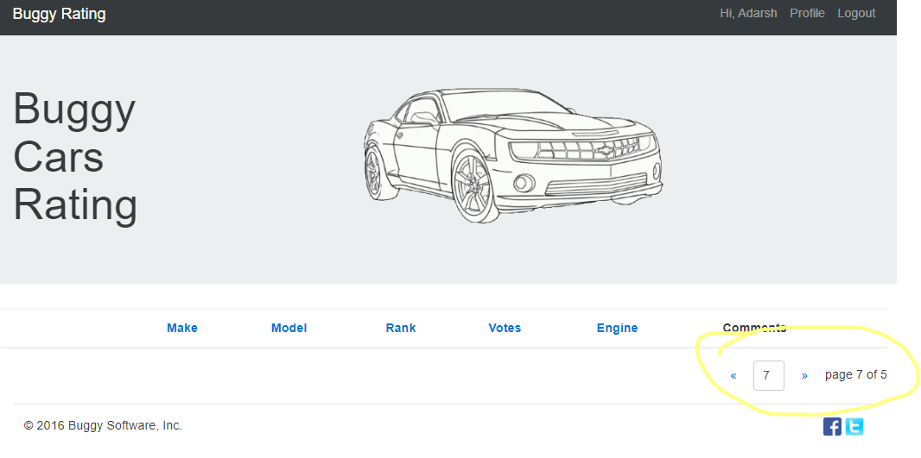

**Bug no.3:**

**Description:** The system allows to change a new password with characters exactly matching with the current password

**Environment –** XYZ

**Date of test –** 07-08-2022

**Team/Project** - XYZ

**Application** – Buggy Cars Rating

**Created by** – Adarsh Ramasubramanian

**Assigned to** – Rakesh Chauhan

**Severity** – Damaging

**Priority** – Medium

**Reproducible** – Yes

**Parent story** – XYZ

**Pre-requisites** – Access to Buggy Cars Rating website

**Steps to reproduce:**

1. Login to <https://buggy.justtestit.org/>
2. Click on the Profile button label in the top right corner to go into Additional Info section
3. Enter the existing password in all three fields – Current password, New password and Confirm password
4. Click on the Save button

**Expected result** – The system should throw some kind of error message to let the user know that all passwords are same

**Actual result** – The system saves without throwing an error message

**Screenshots**:

